Heron dingy for sale
£950
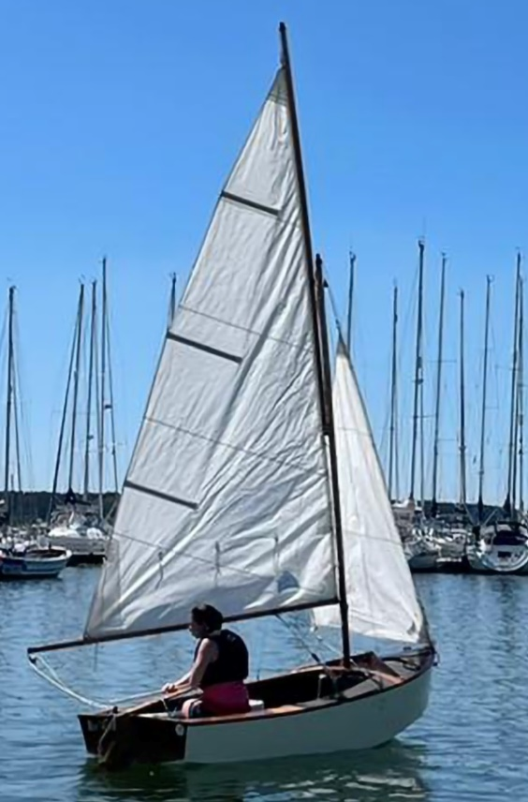
Heron dingy, boat number 8463,
includes:
- Road trailer
- Launching trolley (currently has a puncture but will be fixed before sale)
- 2 x wooden oars
- Rudder
- Cover
- 2 sets of sails
- Gunter rig

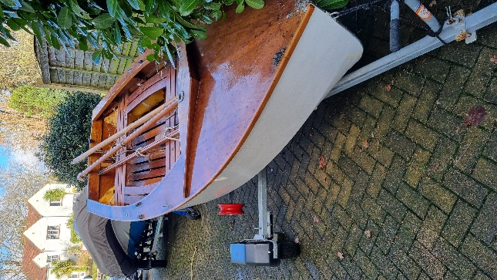
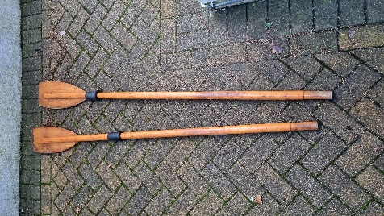
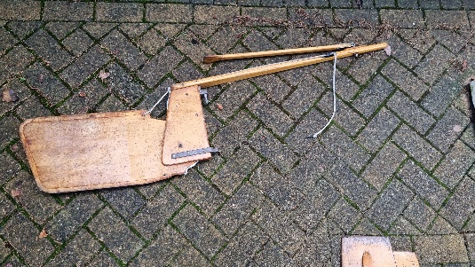
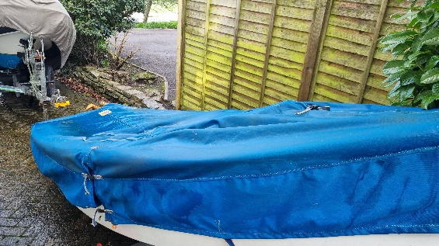
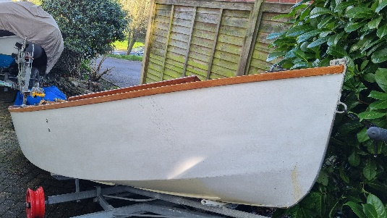

Great condition Heron dingy currently located in Poole, Dorset.

Please contact Becca for more information on 07712124536

